Media: For more information, contact SeaWorld/Aquatica Public Relations at (619) 226-3929.
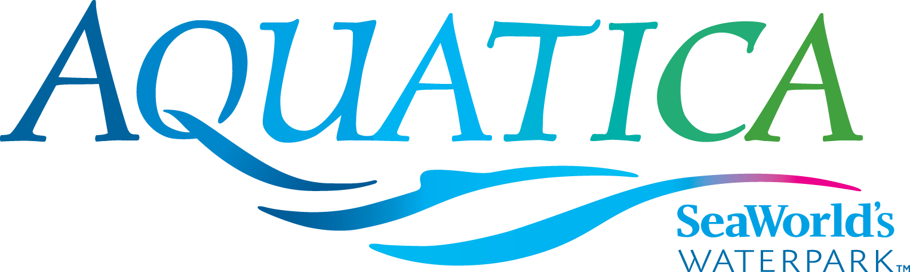

AQUATICA SEAWORLD’S WATERPARK
SET TO MAKE A SPLASH ON MEMORIAL DAY WEEKEND

Aquatica SeaWorld’s Waterpark® is set to make a splash for a fourth season with a combination of high-speed thrills, a relaxing beachside resort atmosphere, up-close animal encounters, and, this year, even more guest conveniences and enhancements, including a new conveyer that will lift rafts up to the top of the park’s popular thrill slide Tassie’s Twister. Comfy water temps are back by popular demand at Big Surf Shores, Slippity Dippity®, Walkabout Waters, Loggerhead Lane and Kata’s Kookaburra Cove® which are all heated to a relaxing 78– to 82-degree temperature! Also adding to guest comfort this year are additional shade structures and lounge chairs. Aquatica San Diego, located near SeaWorld® in Chula Vista, California, opens for the season May 27, 2016.
Aquatica San Diego is a lushly landscaped waterpark with up-close animal experiences, high speed thrills and the amenities of a beachside resort. For those who like life in the fast lane, the Taumata Racer high-speed racing water slide zooms riders down a 375-foot slide, around a 180-degree swooping turn, and in and out of tunnels before racing them across a finish line. Among dozens of other slides and rides at this whimsical, South Seas-themed waterpark is Big Surf Shores, one of the largest wave pools in Southern California, with more than 500,000 gallons of water to take a swim in and a huge sandy beach for basking in the sun. Adventurers should also check out HooRoo Run®, where they have a choice of two enclosed and two open-air slides that take them down an 80-foot descent. Caribbean flamingos and freshwater turtles round out the Aquatica experience, as only SeaWorld can.
Select Pools and Attractions Heated to 78–82 F:
- Big Surf Shores: One of the largest wave pools in Southern California, guests swim in more than 500,000 gallons of water with period swells of up to five feet. A white sandy beach (43,000 square feet!) allows visitors to relax on lawn chairs or luxuriate in nearby cabanas.
- Walkabout Waters: This four-story interactive and colorful outdoor attraction features loads of hands-on fun with slides, hoses, jets, geysers and more. Every five minutes, a 500-gallon bucket unloads water on everyone below!
- Kata’s Kookaburra Cove: Children can splash and play safely in this children’s free-swim area. This kooky, quirky cove has a way of making even a grown-up want to jump right in and play.
- Slippity Dippity: Families with toddlers can splash the day away and let their imagination run rampant as they explore an endless sea of fun at this attraction, which includes kid-sized slides.
- Loggerhead Lane: Guests can swim or float along in an inner tube down a winding 1,250-foot long lazy river, with the added surprise of more than a dozen Caribbean flamingos on display. Playful fountains provide plenty of opportunities to splash while soaking up the sun.
GET YOUR WAVE ON AT:
Rides/Slides:
- Tassie’s Twister: Plunge down a 75-foot water slide in a multi-person raft through thousands of gallons of swirling water before dropping into a six-story funnel. New this year: conveyers that automatically lift rafts to the top of the attraction.
- Taumata Racer: A high-speed racing water slide that zooms riders on six side-by-side lanes down a 375-foot slide, around a 180-degree swooping turn, and in and out of tunnels before racing them across a finish line. Height requirement is 42 inches.
- Whanau Way: Boasting a 60-foot water slide complex featuring six slides, four enclosed and two open air, this ride is a must on any waterpark enthusiast’s list.
- HooRoo Run: Guests can choose their own adventure: two enclosed and two open-air slides await for a thrilling descent down this 80-foot ride.
- Woohoo Falls: Adventurers embark on one of three water slides with speedy twists and turns, including one in the dark for those up to the challenge.
- Kiwi Curl: Guests can put their adrenaline level to the test as they ride down one of three 60-foot-tall water slides. Thrill seekers have the option of sliding in the dark.
- Walhalla Wave: This 78-foot ride is designed for families to enjoy together (height requirement is 42”) in a gigantic tube. A tube lift means no lugging it up the stairs!
Animal Exhibits:
- At Loggerhead Lane, guests enjoy not only a lush tropical attraction with a winding 1,250-foot-long lazy river, but also an up-close view of more than a dozen Caribbean flamingos.
- A habitat with dozens of freshwater turtles, representing several species, live in an exhibit that features under- and above-water viewing.
Guest Amenities:
- Guests can enhance their Aquatica experience with personal cabanas, available poolside at Big Surf Shores and near Loggerhead Lane. Standard, Premium and Ultimate options are available. Guests should check website for availability and pricing prior to their visit.
- Electronic lockers are available for adventurers who need a place to store their land gear before they embark on their water voyage, three sizes to choose from.
- Kiwi Trader’s has waterpark necessities available for purchase, including towels, sunscreen and flip-flops for guests who forgot their waterpark necessities at home.
- Complimentary life vests in all sizes are available for guests as they enter Aquatica.
- Guests can relax on comfortable lounge chairs, with shaded seating located throughout the waterpark.
Aquatica is located at 2052 Entertainment Circle in Chula Vista, California. Operational dates for 2016 are daily May 27–Sept. 5; Saturdays and Sundays, Sept. 10–Oct. 9. Single-day admission is $44 for ages 10 and older; $38 for ages 3–9; free for children under 3. A season Splash Pass costs $44 (does not include parking); a premium season Aquatica Pass costs $89 (includes admission, parking and discounts on food and merchandise); memberships for both SeaWorld San Diego and Aquatica San Diego are available and start at $179. For more information visit www.AquaticaSanDiego.com or call (800) 257-4268.

About SeaWorld Parks & Entertainment
SeaWorld Parks & Entertainment™ is a leading theme park and entertainment company providing experiences that matter and inspiring guests to protect animals and the wild wonders of our world.
SeaWorld Parks & Entertainment is one of the world’s foremost zoological organizations and a global leader in animal welfare, training, husbandry and veterinary care. The company collectively cares for what it believes is one of the largest zoological collections in the world and has helped lead advances in the care of animals. The company also rescues and rehabilitates marine and terrestrial animals that are ill, injured, orphaned or abandoned, with the goal of returning them to the wild. The SeaWorld rescue team has helped more than 27,000 animals in need over the last 50 years.
The company owns or licenses a portfolio of globally recognized brands including SeaWorld®, Shamu® and Busch Gardens®. Over its more than 50-year history, the company has built a diversified portfolio of 11 destination and regional theme parks that are grouped in key markets across the United States, many of which showcase its one-of-a-kind zoological collection of over 800 species of animals. The company’s theme parks feature a diverse array of rides, shows and other attractions with broad demographic appeal which deliver memorable experiences and a strong value proposition for its guests.
SeaWorld Parks & Entertainment is a wholly owned subsidiary of SeaWorld Entertainment, Inc., a publicly traded company. Copies of this and other news releases as well as additional information about SeaWorld Entertainment, Inc. can be obtained online at www.seaworldentertainment.com.

—Aquatica—

Created: May 2016

