Media: For more information, contact SeaWorld Public Relations at (619) 226-3929.
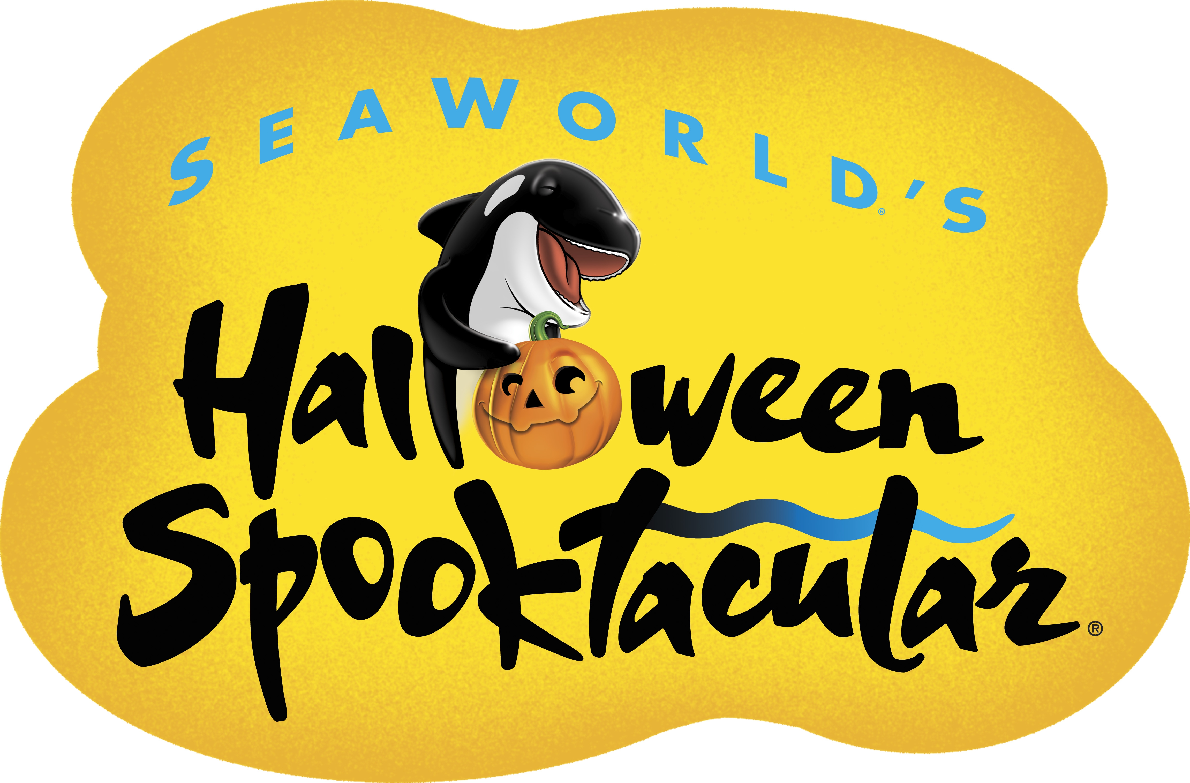

GET READY TO CARVE OUT A GHOULISHLY GOOD TIME

AT SEAWORLD’S HALLOWEEN SPOOKTACULAR!
Plus Kids Can Visit the Park for Free Through October

SAN DIEGO (Sept. 16, 2016) — Whoever said Halloween is only a night of fright hasn’t celebrated this boootiful holiday at SeaWorld San Diego®! SeaWorld announces its Halloween Spooktacular®, San Diego’s premiere not-too-spooky family-fun extravaganza. This must-see fangtastic experience kicks off Sept. 24–25 and runs every weekend in October.
And how’s this for the ultimate treat without a trick: SeaWorld is offering one child, aged 3 to 9, free admission with one full-paid adult admission through October, making this fun-filled day at the park an even greater value!
New this year for Spooktacular will be a family-friendly celebration of the Mexican holiday Dia de los Muertos. Large, beautifully dressed Catrina statues will welcome guests as they discover ofrendas (offerings) of mementos and flowers honoring loved ones who have left us.
Children 12 and under are encouraged to dress up in their finest Halloween costumes for a howling good time at this year’s festivities that includes free candy at 12 underwater-themed trick-or-treating stations. Guests can also creep over to the Clyde & Seamore’s Big Halloween Bash performance at the park’s Sea Lion and Otter Stadium, where those prank-loving sea lions, Clyde® and Seamore®, and the always-mischievous O.P. Otter® get their Halloween on. Plus, Mission Bay Theater will be the ghostly home for Sesame Street’s live show, Who Said Boo?, starring Elmo and his friends as they sing, dance and romp their way through Count’s Castle.
Monsters of all sizes can do the mash at the Spooktacular dance party! DJ Cotton Candy will spin sweet beats that will set the bewitching vibe for the ghoulishly fun costume party! On the dance floor, guests can mingle with candy-inspired characters such as Colonel Candy Corn, Lolly Pop N’ Lockit, and Goody Gumdrop, the King of Candy, plus new this year, Tabitha Taffy and Timothy Toffee.
Youngsters can also let their creative Halloween juices run wild while decorating cookies, painting pumpkins, and, at the kinetic sand bar, building sandy masterpieces.
In addition to taking advantage of SeaWorld’s free single-day child ticket with one full-paid adult admission, dads and mummies can unwrap the same offer at Dine With Shamu® where each child dines free with the purchase of a full-paid adult, all at poolside tables near SeaWorld’s family of killer whales. Plus, a child age 10 to 12 can participate for free in SeaWorld’s Dolphin Interaction Program or Beluga Interaction Program with one full-priced adult participant per interaction (children must be at least 4 feet tall to participate).
SeaWorld is open year-round and has a variety of admission ticket offers that provide tremendous value perfect for both Southern California residents as well as tourists visiting San Diego. Park hours vary by season. Visit www.SeaWorldSanDiego.com or call (800) 257-4268 for hours and information.

About SeaWorld Parks & Entertainment
SeaWorld Parks & Entertainment™ is a leading theme park and entertainment company providing experiences that matter and inspiring guests to protect animals and the wild wonders of our world. The company is one of the world’s foremost zoological organizations and a global leader in animal welfare, training, husbandry and veterinary care. The company collectively cares for what it believes is one of the largest zoological collections in the world and has helped lead advances in the care of animals. The company also rescues and rehabilitates marine and terrestrial animals that are ill, injured, orphaned or abandoned, with the goal of returning them to the wild. The SeaWorld® rescue team has helped more than 28,000 animals in need over the last 50 years.
The company owns or licenses a portfolio of recognized brands including SeaWorld, Busch Gardens® and Sea Rescue®. Over its more than 50-year history, the company has built a diversified portfolio of 12 destination and regional theme parks that are grouped in key markets across the United States, many of which showcase its one-of-a-kind zoological collection of over 800 species of animals. The company’s theme parks feature a diverse array of rides, shows and other attractions with broad demographic appeal which deliver memorable experiences and a strong value proposition for its guests.
SeaWorld Parks & Entertainment is a wholly owned subsidiary of SeaWorld Entertainment, Inc., a publicly traded company. Visit www.SeaWorldEntertainment.com for more information.

—SeaWorld—

