Media: For more information, contact SeaWorld/Aquatica Public Relations at (619) 226-3929.

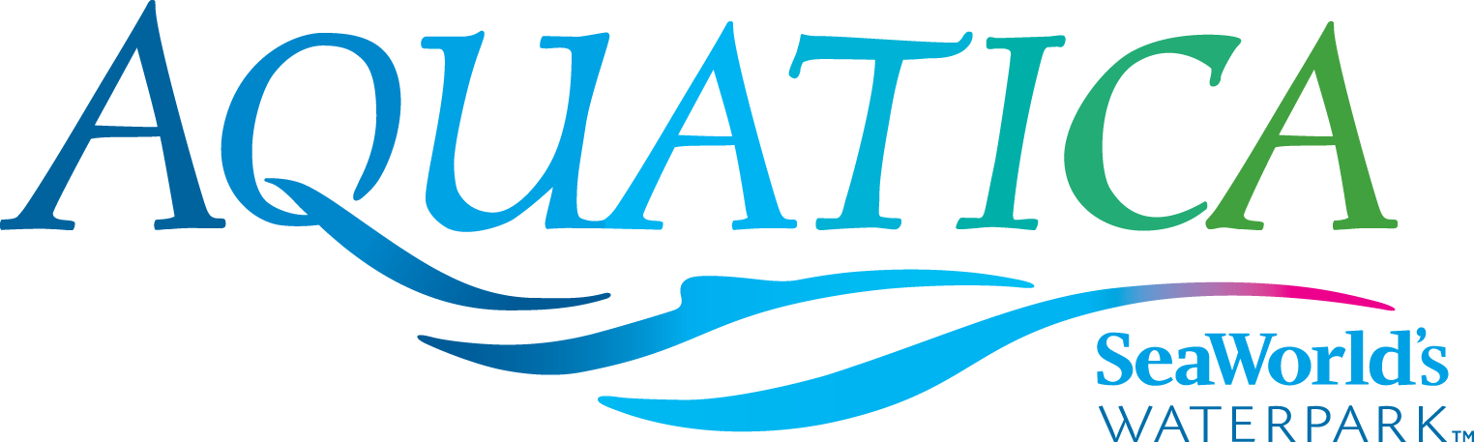

AQUATICA SEAWORLD’S WATERPARK IN SAN DIEGO
2016 GENERAL FACT SHEET

Admission:
Single-Day ticket is $44 for guests ages 10 and older; $38 for ages 3–9; free for guests 2 years old and younger. All slides, rides, pools and beach areas are included with admission. Food, merchandise, cabanas and lockers are optional and available at an additional cost. Park capacity is limited. The best way to splash and play all summer long is the Aquatica Splash Pass. Come back again and again all for the price of a single-day admission ($38 and $44). The Aquatica 2016 Season Pass, which offers unlimited admission for the entire season, free parking and in-park discounts, is $89 for ages 3 and older. Pass Memberships for both SeaWorld San Diego and Aquatica are available, starting at $179.
Parking: $15 for cars, $20 for RVs and campers, $10 for motorcycles
Hours & Location:
Open 10 a.m. Operational dates for 2016 are daily May 27–Sept. 5; Saturdays and Sundays, Sept. 10–Oct. 9. Located at 2052 Entertainment Circle in Chula Vista, CA 91911. Closing times vary; check website (www.AquaticaSanDiego.com).

Lockers: All-day electronic locker rentals are available and conveniently located at the park entrance. Standard, Large and Jumbo locker prices are $12, $15, or $20 per day.
Cabana Rentals:
- Standard Cabanas (starting at $99): Located along Loggerhead Lane; includes a welcome basket, mini-fridge, bottled water and Wi-Fi access. Price includes four guests (up to 2 additional guests may be added for an additional fee). Maximum of six guests allowed per Standard Cabana.
- Premium Cabanas (starting at $119): Private poolside cabana with private beach overlooking Big Surf Shores or Loggerhead Lane includes a welcome basket, mini-fridge, bottled water and Wi-Fi access. Price includes four guests: up to two additional guests may be added for an additional fee and must be purchased at the park upon check in. Price includes four guests (up to two additional guests may be added for an additional fee). Maximum of six guests allowed per Premium Cabana.
- Ultimate Cabanas (starting at $199): Located near Big Surf Shores, Ultimate Cabanas are the largest cabanas available and include welcome basket, mini-fridge, bottled water and Wi-Fi access. Price includes eight guests: up to four additional guests may be added for an additional fee and must be purchased at the park upon check in. Subject to availability. Maximum 12 guests allowed per Ultimate Cabana.

Lounger Rentals:
- Loungers (starting at $34.99): Located along Loggerhead Lane; includes 2 lounge chairs, large umbrella and PoolSafe. PoolSafe is conveniently located alongside your loungers and provides a safe place for your belongings as well as a charging station for your mobile device. Price includes two guests. Maximum of two guests allowed per Lounger rental.

Guest Amenities:
- Big Surf Shores, Loggerhead Lane, Slippity Dippity®, Walkabout Waters and Kata’s Kookaburra Cove® are all heated to a relaxing 78– to 82-degree temperature!
- Gift shop and merchandise carts with waterpark necessities
- Complimentary life vests in all sizes available for guests
- Comfortable lounge chairs (some with umbrellas)
- Shaded seating throughout the park
- Cashless Wristbands: Waterproof wristbands allow for convenient purchases without worrying about misplacing cash or credit cards
- Rafts are provided depending on the ride
Guests Services:
- Located at park entrance
- Can assist with:
  - Visitor information
  - Guides for guests with disabilities
  - Travel assistance
  - Lost & Found
  - Lost children
  - General park information and assistance

Ride Guidelines:
- Guests who may be pregnant, have high blood pressure, heart, neck or back problems, motion sickness, recent surgery, or any other medical conditions may be affected by the features of the ride.
- Those under 42 inches are recommended to wear a life vest and must be accompanied by an adult. Life vests are required at many attractions based on height.

Insider Tips:
- Appropriate swim attire must be worn throughout at all times: bathing-suit thongs are not allowed and children in diapers are required to use waterproof protectors.
- In order to guarantee guest comfort and safety, Aquatica San Diego's capacity is limited. Admission into the park may be suspended during the day due to periods of high attendance.
- Be sun smart! Guests who forgot to bring sunscreen may purchase it at Kiwi Traders.

For more information: Call (800) 257-4268 or visit www.AquaticaSanDiego.com.

—Aquatica—

