Media: For more information, contact SeaWorld/Aquatica Public Relations at (619) 226-3929.

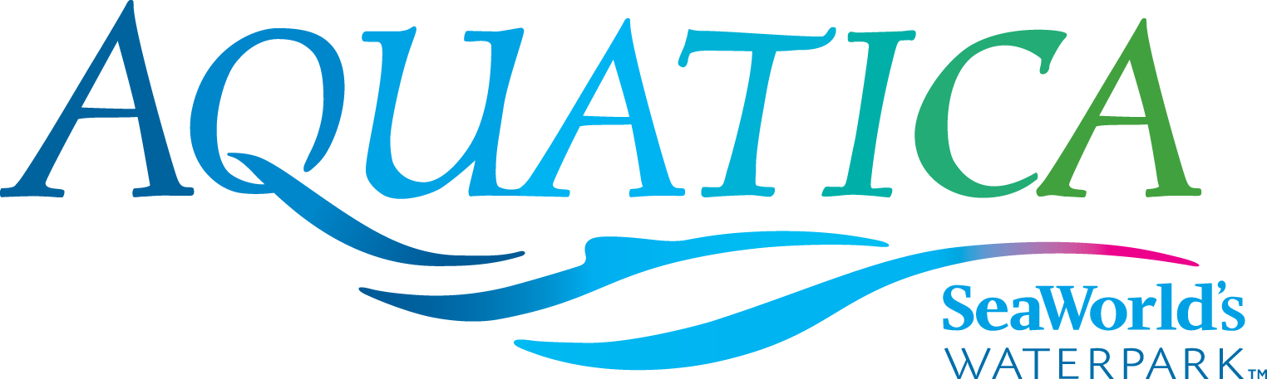

AQUATICA SEAWORLD’S WATERPARK
CULINARY DELIGHTS

From Savory to Sweet, There’s a Treat for Every Taste Bud
Aquatica SeaWorld’s Waterpark® in Chula Vista has several different dining options, including healthy alternatives. Guests looking for fun, unique foods inspired by fresh California flavors will find a meal to match almost any appetite throughout the waterpark.
New this season, guests of all ages can cool off with a watermelon, mango, lemon or blue raspberry Italian ice at the new Buongusto Italian ice cart, located near Taumata Racer. Guests 21 and older will find even more draft and packaged craft beer selections to choose from this season, including Pizza Port and New Belgium in 16-ounce craft cans. Additions to the Karl Strauss lineup include some new and popular varieties on draft, including Mosaic and Aurora Hoppyalis at Rockwater Oasis. Rounding out the new offerings this year is a fresh and bold sandwich, the Baked Chicken Marinara.
Guests who reserve one of Aquatica’s cabanas can have the luxury of food being delivered to them as they relax and enjoy themselves. Menu choices (which are exclusive to cabana guests) include the “Salty Sampler” (chicken tenders, mini corn dogs, jalapeño cheese poppers, tater tots and assorted dipping sauces); the “Pasta Tower” (baked chicken alfredo, three cheese penne-roni marinara and tomato basil baked pasta); and family meals such as the “Cabana Sampler” (bacon-bacon cheeseburger, grilled chicken nacho cone and edamame mixed green salad); and the “Fry Cone Trio” (California cheesesteak, grilled chicken nacho and chili verde french fry). Cabanas also come with a complimentary basket with fruit and salted nuts.
Here’s a look at Aquatica’s eateries:
Waterstone Grill:
- Fry Cones
  - French Fry Cone, Chili Verde Pulled Pork, Pico de Gallo
  - California Cheesesteak, Nacho Cheese, Pico de Gallo
  - Grilled Chicken Nacho Cone, Jalapeño Cheese Sauce, Fresh Salsa
  - Chicken Tender Fry Cone, BBQ/Ranch Sauce
- Burgers
  - 100% pure beef, no additives, no preservatives, crisp lettuce, tomatoes, pickles, Aquatica specialty sauce
    - Hamburger
    - Double Hamburger
    - Cheeseburger
    - Double Cheeseburger
    - Bacon, Bacon Cheeseburger
    - French Fries
- Fresh Greens
  - Chicken Caesar Salad Wrap
  - Edamame Mixed Green Salad Wrap, Tomatoes, Miso Dressing
  - Asian Chicken Salad, Crisp Wonton, Pineapple, Sesame Ginger Dressing
- Hot and cold beverages
Big Surf Snacks:
- Salty
  - Chicken Tenders
  - Corn Dog Bites
  - Jalapeño Cheese Poppers
  - Jumbo Shrimp
  - Tater Tots
  - French Fries
- Salty & Sweet
  - Fried Chicken & Half Funnel Cake, Maple Syrup
  - Tater Tots & Fresh Strawberries, Hot Fudge
- Sweet
  - Funnel Cake, Strawberries & Soft Serve
  - Funnel Cake & Powdered Sugar
  - Waffle Cone Sundae, Hot Fudge or Strawberry
  - Fresh Strawberry Cup
  - Peanut Butter & Jelly Sandwich
- Sauces: Ranch, Organic Ketchup, Barbecue

Mango Market:
- NEW—Baked Chicken Marinara Sandwich
- Baked Chicken Alfredo Pasta
- Three Cheese Penne-roni
- Tomato Basil Baked Pasta
- Italian Caesar Salad, Pizza Croutons
- Tomato Mozzarella Salad
- California Cheese Pizza
- Pepperoni Pizza
- BBQ Chicken Pizza

Island Market:
- Chow Mein Chicken Stir Fry
  - Ginger Soy Marinated Chicken, Cabbage, Carrots, Noodles
- Chow Mein Vegetable Tofu Stir Fry
  - Fresh Tofu, Spicy Teriyaki Sauce, Fresh Vegetable, Noodles
- Chicken Burrito
  - Flour Tortilla, Crisp Lettuce, Roasted Corn, Black Beans, Pico de Gallo Salsa, Guacamole, Sour Cream, Flame-Broiled Citrus Chili Chicken
- The Salad
  - Crisp Lettuce, Roasted Corn, Black Beans, Pico de Gallo Salsa, Guacamole, Sour Cream, Crunchy Tortilla Chips, Flame-Broiled Citrus Chili Chicken
- Chicken Quesadillas
- Turkey Leg
- Hot Dog & Chips Combo
- Chips and Takis

Rockwater Oasis:
- Draft beer by Karl Strauss
  - NEW—Mosaic and Aurora Hoppyalis
  - Red Trolley
  - Sky Tower Golden Ale

- Beer Bottles
  - Bud Light
  - Budweiser
  - Bud Light Lime
  - Michelob Ultra
  - Stella Artois
  - Shock Top
  - Montejo

- Wine
  - Chardonnay
  - Merlot
  - Moscato
- Margaritas
  - Lemon Lime
  - Pina Colada
- Margarita in a Pineapple
- Salted Snacks, Chips

Taumata Craft Brew:
- Taste of Brews
  - NEW—Pizza Port, New Belgium and Shock Top now available in 16-ounce cans
  - Choice of four sample sizes
    - Groundswell Blonde
    - Stone IPA
    - NEW—Belgium Citradelic
    - Mike Hess Grapefruit Solis
  - Assorted Snacks, Chips

Banana Beach Cook-out
- All American Picnic
  - “Build Your Own” Burger, Hot Dogs, Potato Salad, Fresh Watermelon, Aquatica’s Famous “Mac & Cheese”, Vegetarian Baked Beans, Picnic Greens

Aquatica is located at 2052 Entertainment Circle in Chula Vista, California. Operational dates for 2016 are daily May 27–Sept. 5; Saturdays and Sundays, Sept. 10–Oct. 9. Single-day admission is $44 for ages 10 and older; $38 for ages 3–9; free for children under 3. A season Splash Pass costs $44 (does not include parking); a premium season Aquatica Pass costs $89 (includes admission, parking and discounts on food and merchandise); memberships for both SeaWorld San Diego and Aquatica San Diego are available and start at $179. For more information visit www.AquaticaSanDiego.com or call (800) 257-4268.

—Aquatica—

Updated: July 2016

