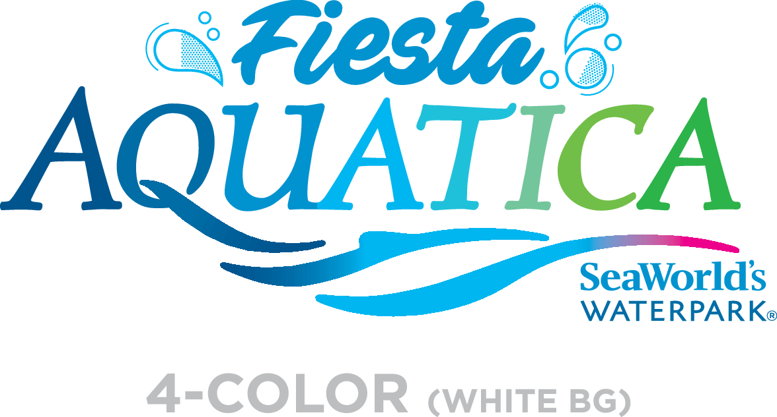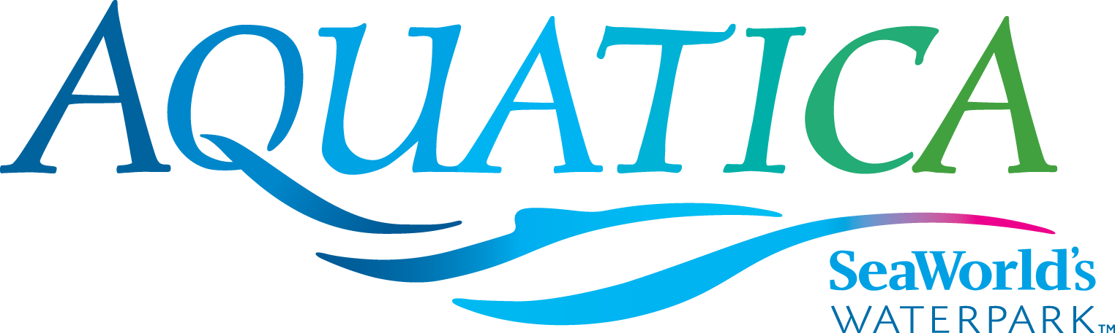

Media: For more information, contact SeaWorld/Aquatica Public Relations at (619) 226-3929.

TAUMATA RACER IS A GUEST FAVORITE AT AQUATICA SAN DIEGO
For those who prefer life in the fast lane, Taumata Racer® is just the ticket! This high-speed racing water slide at Aquatica SeaWorld’s Waterpark® zooms riders down a 375-foot slide, around a 180-degree swooping turn, and in and out of tunnels before racing them across the finish line. Taumata Racer, located between Walhalla Wave® and Kata’s Kookaburra Cove® on the northwest side of the park, is one of Aquatica’s fastest slides and has a minimum height requirement of 42 inches.
“Taumata Racer is definitely a fan favorite at Aquatica,” said Carlos Cuevas, the waterpark’s vice president. “This mat-racer water slide is a unique blend of competitive racing and high-speed thrills. Taumata Racer, which debuted in 2014, is an experience that family and friends can enjoy together and is exactly the type of attraction that makes Aquatica an even more exciting waterpark.”
Taumata Racer, manufactured by ProSlide of Ontario, Canada, features six side-by-side lanes. Park guests speed down the steep hill (60 feet) on a mat head first. The minimum height requirement is 42 inches.
Taumata Racer is as memorable for its fun and excitement as it is for its name. Named for a famous hill in New Zealand, Taumata is short for the 85-letter Maori word “Taumatawhakatangihangakoauauotamateaturipukakapikimaungahoronukupokaiwhenua-kitanatahu.” Roughly translated, this Guinness Book of World Records word means “The summit where Tamatea, the man with the big knees, the climber of mountains, the land-swallower who traveled about, played his flute to his loved one.”
Aquatica San Diego, a lushly landscaped waterpark, combines up-close animal experiences, high speed thrills and the amenities of a beachside resort. Among dozens of slides and rides at this whimsical, South Seas-themed waterpark is Big Surf Shores, one of the largest wave pools in Southern California, and Loggerhead Lane where guests can float in an inner tube along a 1,250-foot lazy river. All of the resort pools and children’s attractions are heated to 78-80 degrees (this includes Big Surf Shores, Loggerhead Lane, Kata’s Kookaburra Cove®, Walkabout Waters and Slippity Dippity). Caribbean flamingos and freshwater turtles round out the Aquatica experience, as only SeaWorld® can.
Aquatica is located at 2052 Entertainment Circle in Chula Vista, California. Operational dates for 2017 are daily May 26–Aug. 27, Aug. 31-Sept. 4, and weekends Sept. 9–Oct. 8. Single-day admission is $46 for ages 10 and older; $40 for ages 3–9; free for children under 3. The season Splash Pass costs $46 (and does not include parking); a premium season Aquatica Pass costs $89 (includes admission, parking and discounts on merchandise and food). Memberships for both SeaWorld San Diego and Aquatica San Diego are available and start at $219. For more information visit www.AquaticaSanDiego.com or call (619) 222-4SEA.

About SeaWorld Parks & Entertainment
SeaWorld Parks & Entertainment™ is a leading theme park and entertainment company providing experiences that matter and inspiring guests to protect animals and the wild wonders of our world. The company is one of the world’s foremost zoological organizations and a global leader in animal welfare, training, husbandry and veterinary care. The company collectively cares for what it believes is one of the largest zoological collections in the world and has helped lead advances in the care of animals. The company also rescues and rehabilitates marine and terrestrial animals that are ill, injured, orphaned or abandoned, with the goal of returning them to the wild. The SeaWorld® rescue team has helped more than 29,000 animals in need over the last 50 years.
The company owns or licenses a portfolio of recognized brands including SeaWorld, Busch Gardens® and Sea Rescue®. Over its more than 50-year history, the company has built a diversified portfolio of 12 destination and regional theme parks that are grouped in key markets across the United States, many of which showcase its one-of-a-kind zoological collection. The company’s theme parks feature a diverse array of rides, shows and other attractions with broad demographic appeal which deliver memorable experiences and a strong value proposition for its guests.
SeaWorld Parks & Entertainment is a wholly owned subsidiary of SeaWorld Entertainment, Inc., a publicly traded company. Visit www.seaworldentertainment.com for more information.

—Aquatica—

Created: April 2017

