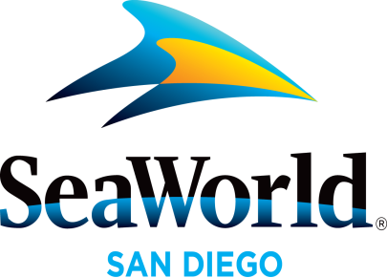

News Media
Tip Sheet

April 2016
SEAWORLD HAS THE MAGIC TOUCH: The highly-anticipated event, SeaWorld’s Magic Weekends, takes center stage at SeaWorld® San Diego beginning April 2. This limited-time engagement shines the spotlight on the most captivating performance art that has enchanted and entertained children and adults alike for centuries. During the April 2–3 weekend, reality TV magic star Steve Wyrick will have guests gasping in amazement with his motorcycle vanish and virtual reality sawing; notable “America’s Got Talent” standout Michael Grasso will amp the adrenaline up with his dynamic presence and unbelievable skills April 9–10; magician David Thomas will bring the “World of Magic” show and Las Vegas-style illusions to guests April 16–17; guests will not want to miss illusionist Rick Thomas’ intriguing and innovative illusions such as the slicer and “Flatin Latin” April 23–24; and magician Michael Turco, who has been featured on “Masters of Illusion,” will leave the audience captivated April 30–May 1. All shows will be performed live at SeaWorld’s Mission Bay Theater. For more information visit: www.SeaWorldSanDiego.com
SEAWORLD HELPS WITH COASTLINE CLEANUP: SeaWorld® San Diego will join volunteers from all over the county for this year’s I Love a Clean San Diego’s Creek to Bay Cleanup, 9 a.m. to noon, April 23. As one of the site captains of the event, SeaWorld will oversee the cleaning of the Mission Bay-South Shores Boat Launch in Zone 3. Last year, more than 5,500 volunteers spanned out across 106 coastal and inland cleanup sites throughout San Diego County, removing nearly 94 tons of debris. For more information, or to register for the Creek to Bay Cleanup, visit www.creektobay.org
SEVEN SEAS FOOD FESTIVAL: Explore and celebrate a world of flavor at SeaWorld Seven Seas Food Festival. Local craft beer and California wine are perfectly paired with fresh and bold culinary creations, which will feature local, sustainable ingredients and unique signature flavors from around the world. New this year is the Polynesian Flavors area featuring delectable island favorites from the Pacific Rim and blazing entertainment. The hub of the festival features California fusion flavors where guests can enjoy the sounds of live bands pulled straight from the San Diego music scene. Environmental messaging, highlighting SeaWorld’s commitment to local sustainable food and recycling will be featured in several festival locations. SeaWorld’s Seven Seas Food Festival dates are May 7–8, 14–15, 21–22 and 28–29; and June 4–5 and 11–12. All of SeaWorld’s seasonal events are included with park admission, but the best way to enjoy all the fun is to purchase a 2016 SeaWorld Fun Card, which costs $10 less than single-day admission and guests can visit all year.
MOTHER’S DAY BRUNCH WITH SHAMU: Families can spend Mother’s Day relaxed and pampered with mom at SeaWorld® while enjoying a leisurely poolside buffet with Shamu® and his trainers. Mother’s Day Brunch With Shamu on May 8 features a special killer whale presentation that highlights the close relationships the killer whales have with each other and their trainers. This one-of-a-kind Mother’s Day experience will entice the whole family with delicious offerings including omelet, French crepe and tri-tip carving stations, mango teriyaki chicken, Spanish rice pilaf, quinoa spinach salad, desserts and more. Space is limited. For more information call (800) 257-4268 or visit www.SeaWorldSanDiego.com.
Photos and videos are available upon request. For more information, please contact SeaWorld® Public Relations at (619) 226-3929, or visit the online Media Room at www.SeaWorld.com/sdpressroom.

—SeaWorld—

