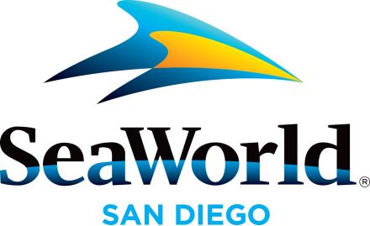
For more information contact SeaWorld Public Relations at (619) 226-3929.

SEAWORLD’S DOLPHIN STADIUM TO UNDERGO

MAJOR REHABILITATION PROJECT

Special presentations will take place at Dolphin Point until

stadium re-opens in April

SAN DIEGO (Jan. 8, 2016) – On Monday (Jan. 11, 2016), a three-month major rehabilitation project will begin at SeaWorld’s Dolphin Stadium. In the interim, special dolphin presentations will be offered at the park’s interaction pools at Dolphin Point. Dolphin Point Playtime presentation times will be listed on the park map and will be free for guests to enjoy daily.
Dolphin Stadium, which seats more than 3,500 guests, was originally built in 1971. Over the last four decades, the stadium has been the venue for many shows, most recently Dolphin Days. The rehabilitation project is a significant infrastructure maintenance investment and will include draining all the pools and re-coating them. The Dolphin Days show can be seen through Sunday (Jan. 10) and will resume when the stadium re-opens in April. The dolphins and pilot whales that currently call Dolphin Stadium home will live in other pools at the park during the project.
During the Dolphin Point Playtime presentations at Dolphin Point, guests will learn about SeaWorld’s dolphins, watch a training session and be inspired to act on what they can do to help protect animals in the wild. In addition, during each presentation, one lucky child will be chosen to participate in a hands-on, one-on-one session with a dolphin, guided by a SeaWorld trainer.
SeaWorld is open year-round including holidays. Admission is $89 for ages 10 and older; $83 for ages 3-9; free for under 3. Parking is $16; $11 for motorcycles; $21 for RVs and Up-Close. SeaWorld’s 2016 Fun Card is a great way to enjoy all the park has to offer this year, all for less than the price of a single-day admission. SeaWorld’s special ticket offers are currently available online. For park hours and more information, visit www.SeaWorldSanDiego.com or call (800) 257-4268.

About SeaWorld Entertainment, Inc.
SeaWorld Entertainment, Inc. (NYSE: SEAS) is a leading theme park and entertainment company providing experiences that matter and inspiring guests to protect animals and the wild wonders of our world.
SeaWorld Entertainment, Inc. is one of the world’s foremost zoological organizations and a global leader in animal welfare, training, husbandry and veterinary care. The company collectively cares for what it believes is one of the largest zoological collections in the world and has helped lead advances in the care of animals. The company also rescues and rehabilitates marine and terrestrial animals that are ill, injured, orphaned or abandoned, with the goal of returning them to the wild. The SeaWorld rescue team has helped more than 27,000 animals in need over the last 50 years.
The company owns or licenses a portfolio of globally recognized brands including SeaWorld®, Shamu® and Busch Gardens®. Over its more than 50-year history, the company has built a diversified portfolio of 11 destination and regional theme parks that are grouped in key markets across the United States, many of which showcase its one-of-a-kind zoological collection of over 800 species of animals. The company’s theme parks feature a diverse array of rides, shows and other attractions with broad demographic appeal which deliver memorable experiences and a strong value proposition for its guests.
Copies of this and other news releases as well as additional information about SeaWorld Entertainment, Inc. can be obtained online at SeaWorldEntertainment.com.

—SeaWorld—

