News Media
Tip Sheet

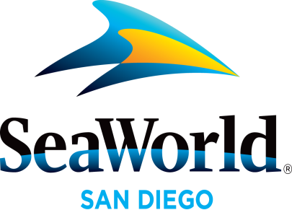

April 2017

SET SAIL ON A CULINARY ADVENTURE: The taps are flowing and internationally-inspired cuisine is served at San Diego’s premiere culinary event, the SeaWorld Seven Seas Craft Beer & Food Festival, Saturdays and Sundays in April. Rising tides of flavor will tantalize the taste buds with gourmet offerings created by SeaWorld® San Diego’s Executive Chef Axel Dirolf and his culinary team. A wave of more than 80 local craft beer samples, more than a dozen wine selections and nearly 60 food samplings allow park guests to indulge in this expanded, five-weekend festival (open 11 a.m. to park close). The Seven Seas Craft Beer & Food Festival is included with park admission, and the best value to experience all SeaWorld’s seasonal events is with the 2017 SeaWorld Fun Card where guests pay for less than a day and play all of 2017 free. For more information, visit www.SeaWorldSanDiego.com or call (619) 222-4SEA.
EASTER WITH SHAMU: Families can spend Easter morning or afternoon relaxed and pampered at SeaWorld® while enjoying a leisurely poolside buffet with our family of killer whales. Easter With Shamu on April 16 features a special killer whale presentation that highlights the close relationships the killer whales have with each other and their trainers. This one-of-a-kind Easter experience will entice the whole family with delicious offerings including oven-roasted beef striploin, a “Grown Up Mac and Cheese Bar”, Dijon herb chicken, sustainable salmon, local summer vegetables, three unique salad choices, desserts and more. Space is limited. For more information call (619) 222-4SEA or visit www.SeaWorldSanDiego.com.
TWO EXCITING ADMISSION OFFERS: For a limited time only, a single-day ticket for weekday admission is now available for only $55, a savings of nearly $40. Complementing the weekday ticket is a new any-day ticket offer at just $69, providing guests nearly $25 in savings. These extraordinary offers let visitors make the most of spring at SeaWorld where they can enjoy all the park has to offer including the one-of-a-kind All Day Orca Play. For the next seven weeks, All Day Orca Play is providing a non-stop series of events and programs showcasing the park’s beloved killer whales during regular park hours. In addition to these great new offers, the SeaWorld Fun Card provides unlimited visits to the park for less than the cost of single-day admission which is perfect for this summer’s debut of the all-new Ocean Explorer, Orca Encounter and Electric Ocean™ nighttime extravaganza. The $55 ticket is valid for weekday visits only through June 16, 2017. The $69 ticket can is valid for a visit any day through June 11, 2017. The $87 Fun Card is valid for unlimited visits in 2017. Offers are only available through advance purchase at www.SeaWorldSanDiego.com or call (619) 222-4SEA.
AQUATICA SAN DIEGO SPLASH PASS: Now is the time to buy early and save with a 2017 Aquatica Splash Pass, which gives guests unlimited admission to Aquatica SeaWorld's Waterpark® all for the price of a single-day ticket. Aquatica San Diego combines high-speed thrills, a relaxing beachside resort atmosphere, up-close animal encounters, and more guest amenities than ever before. Guests can also get double the fun by purchasing a SeaWorld® + Aquatica San Diego 1-Year Membership and not only receive unlimited admission for one year to both SeaWorld San Diego and Aquatica San Diego, but also enjoy free parking, savings on amenities, food, merchandise and up-close experiences. Aquatica San Diego, located at 2052 Entertainment Circle in Chula Vista, California will be open for its fifth season May 26 through Aug. 27 and select dates through October 8. For more information visit: www.AquaticaSanDiego.com.
Photos and videos are available upon request. For more information, please contact SeaWorld® Public Relations at (619) 226-3929, or visit the online Media Room at www.SeaWorld.com/sdpressroom.
—SeaWorld—

