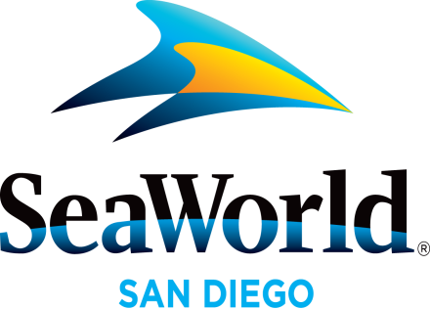

News Media
Tip Sheet

May 2016

SEVEN SEAS FOOD FESTIVAL: Internationally-inspired food takes center stage at SeaWorld® San Diego’s Seven Seas Food Festival kicking off May 7. Guests will be able to explore and celebrate culinary creations created by SeaWorld’s Executive Chef, Axel Dirolf. Local craft beer and California wine are perfectly paired with fresh and bold culinary creations, which feature local, sustainable ingredients and unique signature flavors from around the world. Throughout the park visitors will embark on a global foodie voyage without leaving San Diego enjoying diverse flavors from Nuevo Baja, South America, Asia, France, Mediterranean and the Caribbean. New to this year’s food festival will be the Polynesia and Coca-Cola flavors. Each culinary area features architectural facades that will immerse festival-goers into the cultural landscape of each region. Guests will embrace the island-inspired tastes and aromas at the all-new Polynesian Flavors area. This tropical paradise experience will also be complemented with icy mai tais and piña coladas from the new Tiki bar as well as handcrafted ales and lagers at the Maui Brewing Co. beer cart. Immersive entertainment including high-energy hula and haka performances will have guests dancing with the aloha spirit. Fire dancers will sizzle out the evening and leave guests alight in amazement with blazing performances showing twice nightly. SeaWorld’s Seven Seas Food Festival dates are May 7–8, 14–15, 21–22, 28–30 and June 4–5 and 11–12. For more information visit: www.SeaWorldSanDiego.com/SevenSeas
MOTHER’S DAY BRUNCH WITH SHAMU: Families can spend Mother’s Day relaxed and pampered with mom at SeaWorld® while enjoying a leisurely poolside buffet with Shamu® and his trainers. Mother’s Day Brunch With Shamu on May 8 features a special killer whale presentation that highlights the close relationships the killer whales have with each other and their trainers. This one-of-a-kind Mother’s Day experience will entice the whole family with delicious offerings including omelet, French crepe and tri-tip carving stations, mango teriyaki chicken, Spanish rice pilaf, quinoa spinach salad, desserts and more. Space is limited. For more information call (800) 257-4268 or visit www.SeaWorldSanDiego.com.
AQUATICA SAN DIEGO RETURNS: Aquatica SeaWorld’s Waterpark™ is back to make a splash for a fourth season. With a combination of thrills, a serene beachside resort atmosphere and up-close animal encounters, Aquatica San Diego is the place to be this summer. Opening May 27, guests will delight in the many slides and attractions at Aquatica including the thrilling water slide, Taumata Racer® that rises nearly 60 feet above the ground, zooming riders face down 375 feet on face-down mats before racers across the finish line in their rainbow-hued lanes; Big Surf Shores, a large wave pool with more than 500,000 gallons of water and an expansive sandy beach; HooRoo Run®, where adventurers have a choice of two enclosed and two open-air slides that take them down an 80-foot descent; Loggerhead Lane, a lush tropical attraction with a winding 1,250-foot-long lazy river that features an up-close view of more than a dozen Caribbean flamingos; and a habitat with dozens of freshwater turtles. Aquatica is located in Chula Vista, California. www.AquaticaSanDiego.com.
SUMMER FUN AT SEAWORLD: SeaWorld's got a summer full of good times and good vibrations ready to roll as the park transforms after dark. Starting May 28, SeaWorld is open late with spectacular fireworks and nighttime animal shows. Then the party kicks into high gear June 25 when SeaWorld’s Summer Vibes presented by Coca-Cola reverberates with exciting live entertainment in the park’s Mission Bay Theater. Three international variety acts will bring their amazing talents to SeaWorld on select dates June 25–Aug. 14. In the plaza just outside the theater, guests can be part of the good vibrations during a nighttime party atmosphere pumping with dancing, fun lights and a DJ spinning Top 40 hits. For more information visit: www.SeaWorldSanDiego.com/SummerVibes
For more information, please contact SeaWorld® Public Relations at (619) 226-3929, or visit the online Media Room at www.SeaWorld.com/sdpressroom.

—SeaWorld—

