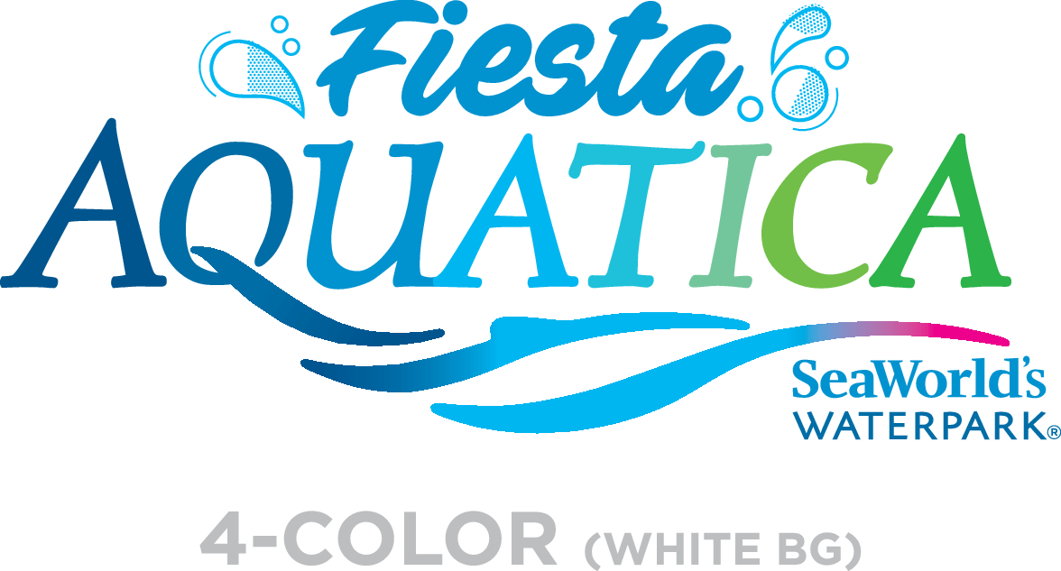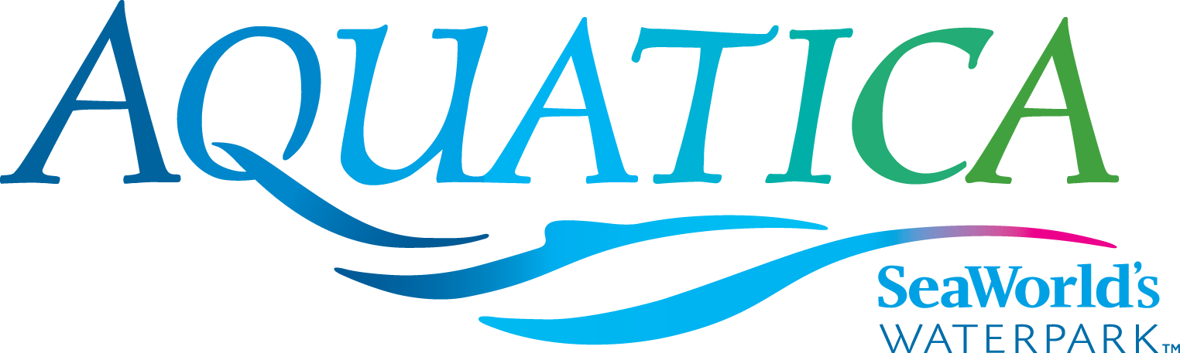

Media: For more information, contact SeaWorld/Aquatica Public Relations at (619) 226-3929.

AQUATICA SEAWORLD’S WATERPARK
CULINARY DELIGHTS

From Savory to Sweet, There’s a Treat for Every Taste Bud
Aquatica SeaWorld’s Waterpark® in Chula Vista has several different dining options, including healthy alternatives. Guests looking for fun, unique foods inspired by fresh California flavors will find a meal to match almost any appetite throughout the waterpark.
Guests of all ages can cool off with a watermelon, mango, lemon or blue raspberry Italian ice at the new Buongusto Italian ice cart, located near Taumata Racer. Guests 21 and older will find even more draft and packaged craft beer selections to choose from this season, including New Belgium, offerings from Chula Vista local Nova Brazil, and Pizza Port in 16-ounce craft cans. The Karl Strauss lineup includes some popular varieties on draft, including Follow the Sun and Aurora Hoppyalis at Rockwater Oasis.
Guests who reserve one of Aquatica’s cabanas can have the luxury of food being delivered to them as they relax and enjoy themselves. Menu choices (which are exclusive to cabana guests) include the “Salty Sampler” (chicken tenders, mini corn dogs, jalapeño cheese poppers, fried cheese sticks and assorted dipping sauces); the “Pasta Tower” (baked chicken alfredo, three cheese penne-roni marinara and tomato basil baked pasta); and family meals such as the “Cabana Sampler” (Chicken Quesadilla, Watermelon and Strawberries, Chili Verde Pulled Pork fry Cone); and the “Fry Cone Trio” (California cheesesteak, grilled chicken nacho and chili verde french fry). Cabanas also come with a complimentary basket with fruit and salted nuts.
Here’s a look at Aquatica’s eateries:
Waterstone Grill:
- Fry Cones
  - French Fry Cone, Chili Verde Pulled Pork, Pico de Gallo
  - California Cheesesteak, Nacho Cheese, Pico de Gallo
  - Grilled Chicken Nacho Cone, Jalapeño Cheese Sauce, Fresh Salsa
  - Chicken Tender Fry Cone, BBQ/Ranch Sauce
- Burgers
  - 100% pure beef, no additives, no preservatives, crisp lettuce, tomatoes, pickles, Aquatica specialty sauce
    - Hamburger
    - Double Hamburger
    - Cheeseburger
    - Double Cheeseburger
    - Bacon, Bacon Cheeseburger
    - Chickpea Burger
    - French Fries
- Fresh Greens
  - Chicken Caesar Salad Wrap
  - Fresh Fruit in Pineapple, Cucumber, Jicama, Chamoy, Tamarind stick
  - Asian Chicken Salad, Crisp Wonton, Pineapple, Sesame Ginger Dressing
- Hot and cold beverages
Big Surf Snacks:
- Salty
  - Chicken Tenders
  - Corn Dog Bites
  - Jalapeño Cheese Poppers
  - Crispy Cheese Sticks
  - French Fries
  - Tater Tots

- Salty & Sweet
  - Fried Chicken & Half Funnel Cake ,Maple Syrup Cone
  - Chicken Tender Fry Cone

- Sweet
  - Funnel Cake, Strawberries & Soft Serve
  - Funnel Cake & Powdered Sugar
  - Waffle Cone Sundae, Hot Fudge or Strawberry
  - Fresh Strawberry Cup

Mango Market:
- Baked Chicken Alfredo Pasta
- Three Cheese Penne-roni
- Tomato Basil Baked Pasta
- Italian Caesar Salad, Pizza Croutons
- Tomato Mozzarella Salad
- California Cheese Pizza
- Pepperoni Pizza
- BBQ Chicken Pizza

Island Market:
- Chow Mein Chicken Stir Fry
  - Ginger Soy Marinated Chicken, Cabbage, Carrots, Noodles
- Chow Mein Vegetable Tofu Stir Fry
  - Fresh Tofu, Spicy Teriyaki Sauce, Fresh Vegetable, Noodles
- Chicken Burrito
  - Flour Tortilla, Crisp Lettuce, Roasted Corn, Black Beans, Pico de Gallo Salsa, Guacamole, Sour Cream, Flame-Broiled Citrus Chili Chicken
- The Salad
  - Crisp Lettuce, Roasted Corn, Black Beans, Pico de Gallo Salsa, Guacamole, Sour Cream, Crunchy Tortilla Chips, Flame-Broiled Citrus Chili Chicken
- Chicken Quesadillas
- Turkey Leg
- Hot Dog & Chips Combo
- Chips and Takis

Rockwater Oasis:
- Draft beer by Karl Strauss
  - Aurora Hoppyalis
  - Red Trolley
  - Sky Tower Golden Ale
  - Follow the Sun Kolsch

- Beer Bottles
  - Bud Light
  - Budweiser
  - Bud Light Lime
  - Michelob Ultra
- Draft
  - Shock Top
  - Point the Way IPA
  - Stella Artois
  - Tecate

- Wine
  - Chardonnay
  - Merlot
  - Moscato
- Margaritas
  - Lemon Lime
  - Pina Colada
- Margarita in a Pineapple
- Salted Snacks, Chips

Taumata Craft Brew:
- Taste of Brews
  - Pizza Port, New Belgium,Shock Top , Nova Brazil now available in 16-ounce cans
  - Choice of four sample sizes
    - Ballast Point Bonito Blonde
    - Stone IPA
    - NEW—Belgium Citradelic
    - Mike Hess Grapefruit Solis
  - Pretzels
  - Margaritas

Aquatica is located at 2052 Entertainment Circle in Chula Vista, California. Operational dates for 2017 are Operational dates for 2017 are daily May 26–Aug. 27, Aug. 31-Sept. 4, and weekends Sept. 9–Oct. 8. Single-day admission is $46 for ages 10 and older; $40 for ages 3–9; free for children under 3. A season Splash Pass costs $46 (does not include parking); a premium season Aquatica Pass costs $89 (includes admission, parking and discounts on food and merchandise); memberships for both SeaWorld San Diego and Aquatica San Diego are available and start at $219. For more information visit www.AquaticaSanDiego.com or call (619) 222-4SEA.

—Aquatica—

Updated: April 2017

