Media: For more information, contact SeaWorld/Aquatica Public Relations at (619) 226-3929.
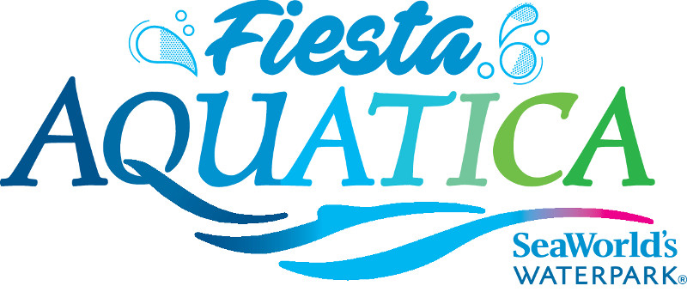

SPLISH SPLASH WITH FIESTA AQUATICA, SEAWORLD’S WATERPARK
Celebrate Aquatica’s 5th Birthday All Summer Long

CHULA VISTA, CALIFORNIA (May 25, 2017) — Put on your best fiesta face with a splish splash birthday bash, dance parties, DJs and more at Fiesta Aquatica, SeaWorld’s waterpark. Beginning May 26, Aquatica’s fifth birthday fiesta will be chillin’ all summer long.
Aquatica has fun for everyone! During the Fiesta Aquatica Beach Party Celebration, live DJs will spin interactive dance tunes and today’s top hits along with some throwback jams, from 3 p.m. to park close. The party atmosphere is popping even more on Fridays through Sept. 1, with Channel 933 on-air personalities keeping the fiesta festivities sizzling. Fiesta Aquatica kicks off June 2 and runs through Sept. 3.
Aquatica is like no other waterpark, combining high-speed thrills with the amenities of a beachside resort and up-close animal encounters. From serene to extreme, experiences range from lounging on sandy beaches and splashing and playing in heated pools to journeying down high-speed water slides, all amongst a lushly landscaped, South Seas-themed, resort-style environment. For those who like life in the fast lane, the Taumata Racer high-speed water slide zooms riders down a 375-foot slide, around a 180-degree swooping turn, and in and out of tunnels before racing them across a finish line. Among dozens of other slides and attractions are Big Surf Shores, one of the largest wave pools in Southern California; HooRoo Run®, which takes riders down an 80-foot descent; and several children’s attractions including Loggerhead Lane and Slippity Dippity. Caribbean flamingos and freshwater turtles round out the Aquatica experience, as only SeaWorld can.
Select Pools and Attractions Heated to 78–82 F:
- Big Surf Shores: One of the largest wave pools in Southern California, guests swim in more than 500,000 gallons of water with periodic swells of up to five feet. A white sandy beach (43,000 square feet!) allows visitors to relax on lawn chairs or luxuriate in nearby cabanas.
- Walkabout Waters: This four-story interactive and colorful outdoor attraction features loads of hands-on fun with slides, hoses, jets, geysers and more. Every five minutes, a 500-gallon bucket unloads water on everyone below!
- Kata’s Kookaburra Cove: Children can splash and play safely in this children’s free-swim area. This kooky, quirky cove has a way of making even a grown-up want to jump right in and play.
- Slippity Dippity: Families with toddlers can splash the day away and let their imagination run rampant as they explore an endless sea of fun at this attraction, which includes kid-sized slides.
- Loggerhead Lane: Guests can swim or float along in an inner tube down a winding 1,250-foot long lazy river, with the added surprise of more than a dozen Caribbean flamingos on display. Playful fountains provide plenty of opportunities to splash while soaking up the summertime sun.
GET YOUR WAVE ON AT:
Rides/Slides:
- Kiwi Curl: Guests can put their adrenaline level to the test as they ride down one of three 60-foot-tall water slides. Thrill seekers have the option of sliding in the dark. New this year, double tubes made for two people to slide together.
- Taumata Racer: A high-speed racing water slide that zooms riders on six side-by-side lanes down a 375-foot slide, around a 180-degree swooping turn, and in and out of tunnels before racing them across a finish line. Height requirement is 42 inches.
- Tassie’s Twister: After conveyers lift rafts to the top of the attraction, plunge down a 75-foot water slide in a multi-person raft through thousands of gallons of swirling water before dropping into a six-story funnel.
- Whanau Way: Boasting a 60-foot water slide complex featuring six slides, four enclosed and two open air, this ride is a must on any waterpark enthusiast’s list.
- HooRoo Run: Guests can choose their own adventure: two enclosed and two open-air slides await for a thrilling descent down this 80-foot ride.
- Woohoo Falls: Adventurers embark on one of three water slides with speedy twists and turns, including one in the dark for those up to the challenge.
- Walhalla Wave: This 78-foot ride is designed for families to enjoy together (height requirement is 42”) in a gigantic tube. A tube lift means no lugging it up the stairs!
Animal Exhibits:
- At Loggerhead Lane, guests enjoy not only a lush tropical attraction with a winding 1,250-foot-long lazy river, but also an up-close view of dozens of Caribbean flamingos.
- A habitat with more than a dozen freshwater turtles, representing several species, live in an habitat that features under- and above-water viewing.
Guest Amenities:
- Guests can enhance their Aquatica experience with personal cabanas, available poolside at Big Surf Shores and near Loggerhead Lane. Standard, Premium and Ultimate options are available. Guests should check website for availability and pricing prior to their visit.
- Electronic lockers are available for adventurers who need a place to store their land gear before they embark on their water voyage, three sizes to choose from.
- Kiwi Trader’s has waterpark necessities available for purchase, including towels, sunscreen and flip-flops for guests who forgot their waterpark necessities at home.
- Complimentary life vests in all sizes are available for guests as they enter Aquatica.
- Guests can relax on comfortable lounge chairs, with shaded seating located throughout the waterpark.

- Loungers in a semi-private area include a large umbrella, Wi-Fi, two lounge chairs and a food attendant. Standard and premium options are also available. For prices and availability check www.AquaticaSanDiego.com prior to visit.
Located at 2052 Entertainment Circle in Chula Vista, Aquatica is operational daily
May 26–Aug. 27, Aug. 31-Sept. 4, and weekends Sept. 9–Oct. 8. Single-day admission is $46 for ages 10 and older; $40 for ages 3–9. A season Splash Pass costs $46 and does not include parking; a premium season Aquatica Pass costs $89 and includes admission, parking, and discounts on food and merchandise. For more information visit www.AquaticaSanDiego.com or call (619) 222-4SEA.

About SeaWorld Parks & Entertainment
SeaWorld Parks & Entertainment™ is a leading theme park and entertainment company providing experiences that matter and inspiring guests to protect animals and the wild wonders of our world. The company is one of the world’s foremost zoological organizations and a global leader in animal welfare, training, husbandry and veterinary care. The company collectively cares for what it believes is one of the largest zoological collections in the world and has helped lead advances in the care of animals. The company also rescues and rehabilitates marine and terrestrial animals that are ill, injured, orphaned or abandoned, with the goal of returning them to the wild. The SeaWorld® rescue team has helped more than 29,000 animals in need over the last 50 years.
The company owns or licenses a portfolio of recognized brands including SeaWorld, Busch Gardens® and Sea Rescue®. Over its more than 50-year history, the company has built a diversified portfolio of 12 destination and regional theme parks that are grouped in key markets across the United States, many of which showcase its one-of-a-kind zoological collection of over 800 species of animals. The company’s theme parks feature a diverse array of rides, shows and other attractions with broad demographic appeal which deliver memorable experiences and a strong value proposition for its guests.
SeaWorld Parks & Entertainment is a wholly owned subsidiary of SeaWorld Entertainment, Inc., a publicly traded company. Visit www.seaworldentertainment.com for more information.
—Aquatica—

.

